**Minor Dissertation Report**

**on**

**“Freshness Detection in Fruits Using Convolutional Neural Network”**

**Submitted By**

**Name:** Mohd Mohsin Ali

**Roll Number:2008580675010**

**Under the Supervision of**

Professor M.K Dutta



***Department of Computer Science and Engineering***

**CENTRE FOR ADVANCED STUDIES**

**Dr. APJ Abdul Kalam Technical University, Lucknow**

**December 2021-22**

Abstract

Fruits detection is a very important factor in the agricultural industry. Farmers are much affected in the classification of fresh and rotten fruits as compared to a machine. The machine takes less time and effort as compared to the human. So, the proposed model is to detect the freshness of the fruit. In this work, the collected data used two types of fruits (Fresh and Rotten) as input fruit images. The fruits are Apple, Guava, Banana, Lime, Orange, and Pomegranate. A Convolutional neural network extracts the features from fresh and rotten fruit images and Sigmoid is used as a classification function. The performance of the proposed model in the CNN model generated an accuracy of 99.44% on the dataset. The result shows that it can easily classify fresh and rotten fruits. We have also compared to some pre-trained like VGG16, MobileNet, XceptionNet, EfficientNet model as for comparison.

Table of Contents

Abstract iii

Table of Contents iii

List of Figures iii

List of Tables iii

List of Abbreviations iii

Certificate iii

Acknowledgements iii

Chapter 1: Introduction 3

1.1 Background 3

1.2 Context 3

1.3 Purposes 3

1.4 Significance, Scope and Definitions 3

1.5 Dissertation Outline 3

Chapter 2: Literature Review 3

2.1 Historical Background [optional] 3

2.2 Topic 1 3

2.3 Topic 2 3

2.4 Topic 3 3

2.5 Summary and Implications 3

Chapter 3: Research Design 3

3.1 Methodology and Research Design 3

3.2 Participants 3

3.3 Instruments 3

3.4 Procedure and Timeline 3

3.5 Analysis 3

3.6 Ethics and Limitations 3

Chapter 4: Results 3

Chapter 5: Analysis 3

Chapter 6: Conclusions and Future Work 3

References 3

Certificate

The work contained in this report has not been previously submitted to meet requirements for an award at this or any other higher education institution. To the best of my knowledge and belief, the thesis contains no material previously published or written by another person except where due reference is made.

Signature: _________________________

Date: _________________________

Acknowledgements

At first, I want to thank our respected Supervisor, Professor M.K Dutta . Department of Computer Science & Engineering, Centre for advanced studies. This whole time they have supported us, inspired us and showed us the right way. They made it easier for us to work continuously with all their patience and inspirations. Every time we had a difficulty, we contacted them and they helped us with a suggestion and that helped us a lot throughout the whole time

# *Introduction*

The agriculture of India is the main source of income for the farmers. India ranks second worldwide in farm outputs. As of 2018, agriculture employed more than 50% of the Indian workforce and contributed 17–18% to the country’s GDP. [1] The farmers plant various types of fruits and vegetables. Detection of defected fruits and the classification of fresh and rotten fruits represent one of the major challenges in agricultural fields. Rotten fruits may cause damage to the other fresh fruits if not classified properly and can also affect productivity. Traditionally this classification is done by men, which was labor-intensive, time taking, and not efficient procedure. Additionally, it increases the cost of production also. Hence, we need an automated system that can reduce the efforts of humans, increase production, to reduce the cost of production and time of production. [2] A major constraint of framing in developing countries like India is the underutilization of automation and mechanized processes. About 58% of the total Indian population is primarily dependent on agriculture for their livelihood. India has enormous revenue potential in the food processing sector which is destined for the massive expansion of the global food trade. The grocery and food market in India is the world’s sixth-largest, with retail representing 70% of sales revenue. The Indian food processing industry contributes 32% of the overall food market of the country. [3]Previous research in the area of fruits classification is discussed in this section.

## Background

Defective fruits are a leading cause of financial problems for the agricultural agribusiness worldwide. It affects the quality and quality of the fruit. Quality monitoring is a time-consuming and very special process after harvest..

## Context

To Proposed a Convolutional neural network Model with better accuracy Performance

## Purposes

Diseases of fruits and assessment of their quality are one of the key challenges in the farming sector and their automated recognition is very critical to save time and avoid financial loss. The process of manually looking at and identifying the fruit type in crops can be a cumbersome task, the time from which could be put to better use. In this paper, a novel deep learning-based architecture CNN model has been proposed to identify the type of fruit and their quality assessment. The proposed architecture aims to exponentially reduce the time for categorizing real-world images of fruits in multiple visual variations by automating the process through a deep learning model which achieves a high accuracy with fruits.

## Significance, Scope and Definitions

Fruits detection is a very important factor in the agricultural industry. Farmers are much affected in the classification of fresh and rotten fruits as compared to a machine. The machine takes less time and effort as compared to the human. So, the proposed model is to detect the freshness of the fruit. In this work, the collected data used two types of fruits (Fresh and Rotten) as input fruit images. The fruits are Apple, Guava, Banana, Lime, Orange, and Pomegranate. A Convolutional neural network extracts the features from fresh and rotten fruit images and Sigmoid is used as a classification function.

## DISSERTATION OUTLINE

The remainder of the paper is organised in the following manner. The data collection and deep neural network design are discussed in detail in Section II. The outcomes of the experiments were discussed in Section III. The proposed work is concluded in Section IV.

# Literature Review

The literature review of this type of problem been stated here ,the papers which already done in last few year are as follow:

* **Chemometric pre-processing can negatively affect the performance of near-infrared spectroscopy models for fruit quality prediction :**Chemometrics pre-processing of spectral data is generally used to improve predictive outcomes of fresh fruit quality assessment of near-infrared models. Various pre-processing procedures are utilised to eliminate scattering effects and reduction of scattering information degrades the performance of the predictive model because scattering and absorption qualities are very important to describe the physicochemical state of the fruit [4]
* **Tomato Fruit Detection and Counting in Greenhouses Using Deep Learning**:Accurately detecting and counting fruits during plant growth using imaging and computer vision is of importance not only from the point of view of reducing labor intensive manual measurements of phenotypic information, but also because it is a critical step toward automating processes such as harvesting. Deep learning based methods have emerged as the state-of-the-art techniques in many problems in image segmentation and classification, and have a lot of promise in challenging domains such as agriculture, where they can deal with the large variability in data better than classical computer vision methods. This paper reports results on the detection of tomatoes in images taken in a greenhouse, using the MaskRCNN algorithm, which detects objects and also the pixels corresponding to each object. Our experimental results on the detection of tomatoes from images taken in greenhouses using a RealSense camera are comparable to or better than the metrics reported by earlier work, even though those were obtained in laboratory conditions or using higher resolution images. Our results also show that MaskRCNN can implicitly learn object depth, which is necessary for background elimination. [5].
* **Computer vision based detection of external defects on tomatoes using deep learning**.Sorting machines use computer vision (CV) to separate food items based on various attributes. For instance, sorting based on size and colour are commonly used in commercial machines. However, detecting external defects using CV remains an open problem. This paper presents an experimental contribution to external defect detection using deep learning. An uncensored dataset with 43,843 images including external defects was built during this study. The dataset is heavily imbalanced towards the healthy class, and it is available online. Deep residual neural network (ResNet) classifiers were trained that are capable of detecting external defects using feature extraction and fine-tuning. The results show that finetuning outperformed feature extraction, revealing the benefit of training additional layers when sufficient data samples are available. The best model was a ResNet50 with all its layers fine-tuned. This model achieved an average precision of 94:6% on the test set. The optimal classifier had a recall of 86:6% while maintaining a precision of 91:7%. The posterior class conditional distributions of the classifier scores showed that the key to classifier success lies in its almost ideal healthy class distribution. The results also explain why the model does not confuse stems/calyxes with external defects. The best model constitutes a milestone for detecting external defects using CV. Because deep learning does not require feature engineering or prior knowledge about the dataset content, the methodology may also work well with other foods [6].
* **VirLeafNet: Automatic Analysis and Viral Disease Diagnosis Using Deep-Learning in Vigna Mungo Plant**. Various viral diseases affect the growth of the plants that causes a huge loss to farmers. If the viral infection could be noticed at earlier stages, then recovery procedures and respective action can be taken on time. Thus, there is a need for developing automatic viral infection detection methods for monitoring of crops analysing symptoms at different parts of plants. This paper proposes an automatic deep-learning-based viral infection detection method for a leguminous plant, Vigna Mungo which is grown largely in the Indian subcontinent. Due to viral infection, some properties of the leaf image changes but the pattern is very random throughout the leaf structure. Hence, it is quite challenging to make an automatic disease detection method and perform the detection tasks in real-time. The collected image dataset of Vigna Mungo leaves belonging to different categories are segmented and augmented to introduce more variety in the leaf image dataset. The convolutional neural network VirLeafNet is trained with different leaf images consisting of healthy, mild-infected and severely infected leaves for multiple epochs. The proposed methodology can be integrated with drones for wider crop area analysis. The proposed method is completely automatic, nondestructive and quickly classifies the leaf images of different categories in real-time. All the proposed models achieved high validation accuracy and yielded testing accuracy for VirLeafNet-1, VirLeafNet-2, and VirLeafNet-3 as 91.234%, 96.429%, and 97.403% respectively on different leaves images after extensive testing of the algorithm [7]
* **On line detection of defective apples using computer vision system combined with deep learning methods**.A deep-learning architecture based on Convolutional Neural Networks (CNN) and a cost-effective 14 computer vision module were used to detect defective apples on a four-line fruit sorting machine at a 15 speed of 5 fruits/s. A CNN based classification architecture was trained and tested, with the accuracy, 16 recall, and specificity of 96.5%, 100.0%, and 92.9%, respectively, for the testing set. An inferior 17 performance was obtained by a traditional image processing method based on candidate defective 18 regions counting and a support vector machine (SVM) classifier, with the accuracy, recall, and 19 specificity of 87.1%, 90.9%, and 83.3%, respectively. The CNN-based model was loaded into the 20 custom software to validate its performance using independent 200 apples, obtaining an accuracy of 92% 21 with a processing time below 72 ms for six images of an apple fruit [8]
* **Machine Learning–Based Detection and Sorting of Multiple Vegetables and Fruits**Vegetable and fruit security plays a crucial role in the Indian economy. In the recent past, it has been noted that vegetables and fruits are affected by different diseases. This leads to the failure of the economy in the agriculture field. The identification of type and grading of vegetables and fruit is onerous due to the heavy production of products. The manual investigation is expensive, laborious, and inconsistent. Thus, an automated machine learning–based algorithm is proposed for the detection of type and quality grading of five different (jalapeno, lemon, sweet potato, cabbage, and tomato) vegetables and four different (apple, avocado, banana, and orange) varieties of fruits. Firstly, images are preprocessed by Gaussian filtering to enhance the quality of the image and removing of noise. Secondly, segmentation of images is done by fuzzy c-means clustering and grabcut. Then, various features, namely, statistical, color, textural, geometrical, Laws’ texture energy, the histogram of gradients, and discrete wavelet transform, are extracted (114) and selected from feature vector by PCA. The detection of vegetable and fruit types is done by color and geometrical features while all other features are considered for grading. Lastly, LR, SRC, ANN, and SVM are used to make decisions for sorting and grading. [9]
* **A system based on image processing and deep CNN features for classification of defective fruits**Faced with the growing demand for quality products in markets and industries in agricultural sectors .from consumers, sellers, and producers. The research aims to respond to this, by using effective and efficient technologies, namely image processing and computer vision, to automate the process of inspection and evaluation of the quality of agricultural products. Conducted for many years by human experts. The use of these technologies concerns both the detection of fruit diseases and their classification. To follow this concept, we chose to focus our work on fruits classification. whose purpose is to separate infected fruits from those that are not affected. However, based on the concepts of computer vision, the proposed technique is centered on three steps. The first step concerns preprocessing and segmentation, in which, we resize and improve the quality of the images. The second step involves, deep pretrained models (Alex-Net), these are used for the extraction of the features in the different fruits (banana, apples, oranges). And finally, we performed the classification, by using multi-class SVM. [10].
* **An Automated System for Fruit Gradation and Aberration Localisation using Deep Learning**Automated visual inspection using deep learning is widely used in recent years. In the field of agriculture deep learning can be deployed to reduce effective man power, best time utilization and supreme classification with improved accuracy. In agriculture, DL can be imported in many applications like soil identification, disease classification, fruit grading and many more. Fruit quality classification is an essential part in farming as it implies to the return directly. Hence an automated system is much needed to improve the classification of fruits with high accuracy and less time. In this paper a deep neural network CNN is implemented by which the system is able to identify the fruit type and classified weather the fruit is healthy or diseased. This paper also able for aberration localization from the fruit surfaces using R-CNN concept. This work has achieved the optimum result with grading accuracy over 99% and 97.86% using CNN and R-CNN methods respectively. [11].
* **Deep learning based real-time Industrial framework for rotten and fresh fruit detection using semantic segmentation**CMOS Image sensors play a vital role in the exponentially growing field of Artificial Intelligence (AI). Applications like image classification, object detection and tracking are just some of the many problems now solved with the help of AI, and specifically deep learning. In this work, we target image classification to discern between six categories of fruits – fresh/ rotten apples, fresh/ rotten oranges, fresh/ rotten bananas. Using images captured from high speed CMOS sensors along with lightweight CNN architectures, we show the results on various edge platforms. Specifically, we show results using ON Semiconductor’s global-shutter based, 12MP, 90 frame per second image sensor (XGS-12), and ON Semiconductor’s 13 MP AR1335 image sensor feeding into MobileNetV2, implemented on NVIDIA Jetson platforms. In addition to using the data captured with these sensors, we utilize an open-source fruits dataset to increase the number of training images. For image classification, we train our model on approximately 30,000 RGB images from the six categories of fruits. The model achieves an accuracy of 97using ON Semiconductor’s 13 MP camera with AR1335 sensor. In addition to the image classification model, work is currently in progress to improve the accuracy of object detection using SSD and SSDLite with MobileNetV2 as the feature extractor. In this paper, we show preliminary results on the object detection model for the same six categories of fruits. [12]
* **A Design of Deep Learning Experimentation for Fruit Freshness Detection**Indonesia is a country with a tropical climate so that fruit and vegetable plants can grow easily in Indonesia.Fruits have many good nutrients such as vitamins, proteins and others.But the fruit also has a period where the fruit is said to be fresh fruit.During this time there are still many fruit supplier companies that send fruit unfit for consumption due to lack of accuracy in the process of sorting the fruit when the fruit is taken from the plantation and the entry of other fruit into an improper packaging.Thus, it makes detecting food spoilage from the production stage to consumption is very important. [13]

## Summary and Implications

The summary of the literature we have design state art of table

|  |  |  |  |  |  |
| --- | --- | --- | --- | --- | --- |
| S NO | TITLE | MODEL | ACCURACY | PUBLICATION | DATE |
| 1 | Chemometric pre-processing can negatively affect the performance of near-infrared spectroscopy models for fruit quality prediction | PLS And DL | lowest RMSEP of 0.76% | ELSEVIER | 2021 |
| 2 | Tomato Fruit Detection and Counting in Greenhouses Using Deep Learning | MASK RCNN | 75% | Frontiers in Plant Science | 2020 |
| 3 | Computer vision based detection of external  defects on tomatoes using deep learning | DEEP RNN and RESNET | 91.7% | ELSEVIER | 2019 |
| 4 | VirLeafNet: Automatic Analysis and Viral  Disease Diagnosis Using Deep-Learning in  Vigna Mungo Plant | CNN | 97.03% | ELSEVIER | 2020 |
| 5 | On line detection of defective apples using computer vision system combined with  deep learning methods | CNN TRANSFER LEARNING | 96% | ELSEVIER | 2020 |
| 6 | Fresh and Rotten Fruits Classification Using CNN and Transfer Learning | CNN AND PRETRAINED MODEL | 97.82% | IETA | 2020 |
| 7 | Machine Learning–Based Detection and Sorting of Multiple  Vegetables and Fruits | SVM ,ANN, SRC and LR | 97.3% | SPRINGER | 2021 |
| 8 | An Automated System for Fruit Gradation and  Aberration Localisation using Deep Learning | RCNN | 97% | IEEE | 2021 |
| 9 | A system based on image processing and  deep CNN features for classification of  defective fruits | ALEXNET and SVM | 85.7% | ICATCES | 2019 |
| 10 | Deep learning based real-time Industrial framework for rotten  and fresh fruit detection using semantic segmentation | EN -UNET | 97.54% | SPRINGER | 2020 |

# Research Design

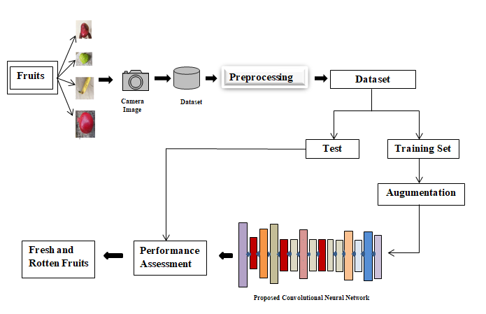

Fig 3 1 Block diagram of Fruit CNN

The above figure no 1 is the design of the binary classification of fresh fruit and rotten fruits. We proposed a convolutional neural model which will give the better accuracy for prediction of fruits We will divide the dataset do the pre-processing for the better result and tackle the overfiting problem, then we start the training portion and passed to the model for the prediction

## Methodology and Research Design

### Methodology

The data set has huge inter-class and intra-class variation in terms of lighting and position of the fruits related to more challenging backgrounds. CNN models are very reliable and are useful in the recognition and categorization of images. A CNN model has some trainable layers and a non-trainable layer. The flattened or fully-connected layer is then connected, for the classification functions. Convolution is an important method, and the convolutional layer is a key component of a CNN model where the convolution of the next signal is a small kernel slides over given fruits image, resulting in a single convolved value that provides an image, resulting in a single convolved value that provides a 2D feature map for eachposition of the kernel. The architecture diagram proposed CNN model is shown in figure.2. The proposed architecture is composed of multiple layers having a different function, stacked to form a combined network for the classification of fresh and rotten fruits. In the initial layer, the images in the data set to be resized to dimension 150×150×3, after which the data encoded is normalized and one-hot vectors for each of the images were computed which is fed into the model, which starts with a single convolutional layer with 3×3 sized 32 filters with a stride of 2, followed by ReLU activation function. A ReLU activation is used in the layers of a deep neural network as it allows for complex non-linearity. The ReLU function can be represented as in (1).

f(x)=max(0,x) (1)

The graph mapped out by this equation has a slope of 1, sigmoid activations for which the learning becomes almost zero for very high or low numbers. A max-pooling layer is then applied to condense the size of the inputs into the next layer. In a max pool layer, the only maximum of the inputs is taken from a kernel fitted over the inputs of the entered size. This max-pooling layer has a kernel size of 2×2 and a strideof 2. The dropout layer used 20% unfit data. This is followed by convolutional layers of 64 filters, with kernel size 3×3, ReLU activation function, and the former having a stride of 2. Another set of batch normalization and max-pooling is next with the same parameters as the last time except a kernel size of 2×2. The final block has a convolutional layer with 124 filters and the continuing trend of kernel size persists as well as the dropout layer and the ReLU function. Flattening of the data into a single channel occurs, after which dense layers of 512 hidden units were added, respectively with ReLU activation function. The last layer of the architecture is unique in the sense that it has a sigmoid activation function unlike other layers of the architecture, which is used for binary classification problems, hence the number of units in this dense layer is also equal to the number of categorized outcomes for a given fruit image i.e. 2. The detailed information of the parameters in different layers is given in Table I. from each convolutional, pooling, and dropout layer of a CNN model. The proposed deep learning architecture of

CNN model predicts the given images of fruits in the category with the most similar extracted characteristics after layer-by-layer processing. Dropout has been used in the proposed model to prevent the occurrence of over-fitting. When fruit quality deteriorates, multiple visual features are generated, and different patterns are recognized and categorized in deep learning. To distinguish from other fresh and rotten fruits photos, based on shape and degradation of fruits various patterns recognize by the proposed deep learning model .

.

### Research Design

Outline the research design (e.g., quantitative, qualitative). If quantitative, spell out the independent, dependent and classificatory variables (and sometimes formulate an operational statement of the research hypothesis in null form so as to set the stage for an appropriate research design permitting statistical inferences). If qualitative, explain and support the approach taken and briefly discuss the data gathering procedures that were [will be] used (observations, interviews, etc.)

## Participants

The member in this dissertation

Name – MohdMohsin Ali

M.tech 2ndyr

Under guidance of.M.K Dutta

## Instruments

The hardware specifications of the training system include Windows 10 operating system with 64 bit Intel Xenon Gold 5218 CPU, the processing speed of 2.30GHz, installed RAM of 64 GB, NVIDIA Quadro P600 Graphics, and 24 GB Graphics Memory. All the programs were deployed in Python languages and implemented using Jupyter Notebook in Anaconda environment. OpenCV, Keras and Tensorflow packages were used to implement the deep learning model and their training.

## Procedure and Timeline

The fruit photo database in 12 different classes is divided into three different sub-sets namely training, validation and test set. As the number of images was large, 12000 randomly selected images in each class were used in the training set and 500 each were distributed between the validation set and the test set. The validation set is provided with a training set that assists the training model to fine-tune its parameters and best suits data points with good accuracy. An in-depth study of the CNN model for automatic fruit classification and quality testing is tested on images in a database after it has been trained 100 times and the loss is complete. Test results confirmed the effectiveness and robustness of the proposed CNN model for fruit identification and quality assurance.

Table.3.1

|  |  |  |  |  |  |  |  |
| --- | --- | --- | --- | --- | --- | --- | --- |
| **No** | **Layers** | **Filters** | **Kernel/**  **Pool Size** | **Stride** | **Activation Function** | **Output Shape** | **Number of Parameters** |
|  | Input Image |  |  |  |  | 150,150,3 |  |
| 1 | 2D Convolutional | 32 | 3x3 | 2 | RELU | 148,148,32 | 896 |
| 2 | Max-Pooling |  | 3x3 | 2 |  | 74,74,32 | 0 |
| 3 | 2D Convolutional | 64 | 3x3 | 2 | RELU | 72,72,64 | 18496 |
| 4 | Max-Pooling |  | 3x3 | 2 |  | 36,36,64 | 0 |
| 5 | Max-Pooling |  | 3x3 | 2 |  | 18,18,64 | 0 |
| 6 | Dropout |  |  |  |  | 18,18,164 | 0 |
| 7 | Max-Pooling | 64 | 2x2 | 2 |  | 9,9,64 | 0 |
| 8 | 2D Convolutional | 124 | 3x3 | 2 | RELU | 7,7,124 | 71548 |
| 9 | Max-Pooling |  | 2x2 | 2 |  | 3,3,124 | 0 |
| 10 | Dropout |  |  |  |  | 3,3,124 | 0 |
| 11 | Fully Connected layer |  |  |  |  | 1116 | 0 |
| 12 | Dense Layer |  |  |  | RELU | 512 | 571904 |
| 13 | Dropout Layer |  |  |  |  | 512 | 0 |
| 14 | Classification Layer |  |  |  | Softmax | 12 | 513 |
| **Trainable Parameters 663,357**  **Non-Trainable Parameters 0**  **Total Parameters 663,357** | | | | | | | |

## Analysis

Table3.2 Analysis of pre-trained model

|  |  |  |
| --- | --- | --- |
| Model | Accuracy(100 epoch) | time |
| Vgg16 | 98.16% | 3 hours 16 min |
| Mobilenet | 97.16% | 3 hours 16 min |
| Efficientnet | 96% | 3 hours 56 min |
| Xception | 98.30% | 3 hours 19 min |
| Proposed Model | 99.44% | 40 min |

The above table will analysed how very well the model is working As we clearly see that vgg16 having the 98.16% accuracy, Mobilenet have 97.16% accuracy with more time taken, Efficientnet having 96% accuracy, Xception showing 98.03% accuracy.

So the proposed model working better than pre-trained model for classification the fresh fruit and rotten fruits

## Ethics and Limitations

In terms of research we can make more reliable divisions, we can reduce training time with more precise planning. We can do more engineering features in the images of this data set. Rotten fruits are the leading cause of financial problems in the agribusiness business worldwide. It affects the quality and quality of the fruit. Quality monitoring is a time-consuming and very special process after harvest. The need for a fast-paced and slow-moving computer model that does not allow for excellent accuracy has been met with this proposed CNN model. After training with 9800 images and 1200 tests to confirm and test each, this produces 99.44% accuracy. This model has room for further improvement as to get the best training time without losing the accuracy that can be achieved, yet more promising is the prospect of using more classes in this model depending on the different types of fruit or. even other plants grown throughout India and the world. The wide variety of fruits and vegetables to be considered and their quality contribute to the high utilization of technology, which allows for flexible classes depending on the farmer's crops, increasing efficiency.

# 

# Results

Using the Adam optimizer, the hyper-parameter reading rate is set to 0.001. Since the labeled code as a vector single-hot categorical crossentropy was used as a loss function, the metrics were accurate. The model was then suitable for using a batch size of 32, and the system was made of 72 epoch to ensure no major instability or sudden crash. Training accuracy, validation accuracy, training loss, and validation loss are calculated and presented in Fig. 4. It is clear that as the number of epoch increases, both the training and the loss of validation decreases and thereafter, the accuracy of the training and certification has increased remarkably. The highest 100% authenticity and the lowest validity loss were found to be 0.0022. Finally, 99.4% accuracy was achieved with the proposed model in the experimental set that included the invisible. The confusion matrix is ​​a square grid that combines the number of classes such as length and width, where the sum of the numbers corresponding to the diagonal line from top to bottom right, for better system performance. This is because the value associated with these blocks gives the number of true points, the images labeled as a particular category and the model predicted as such. The confusion matrix found in the test set is given in Fig4.3.

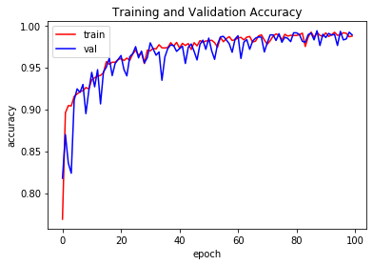

Fig.4.1 Training and validation accuracy curve

The above is training and validation Accuracy showing quite good

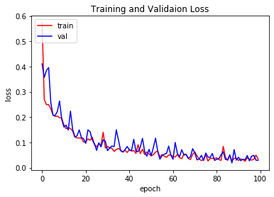

Fig.4.1 Training and validation Loss curve

. 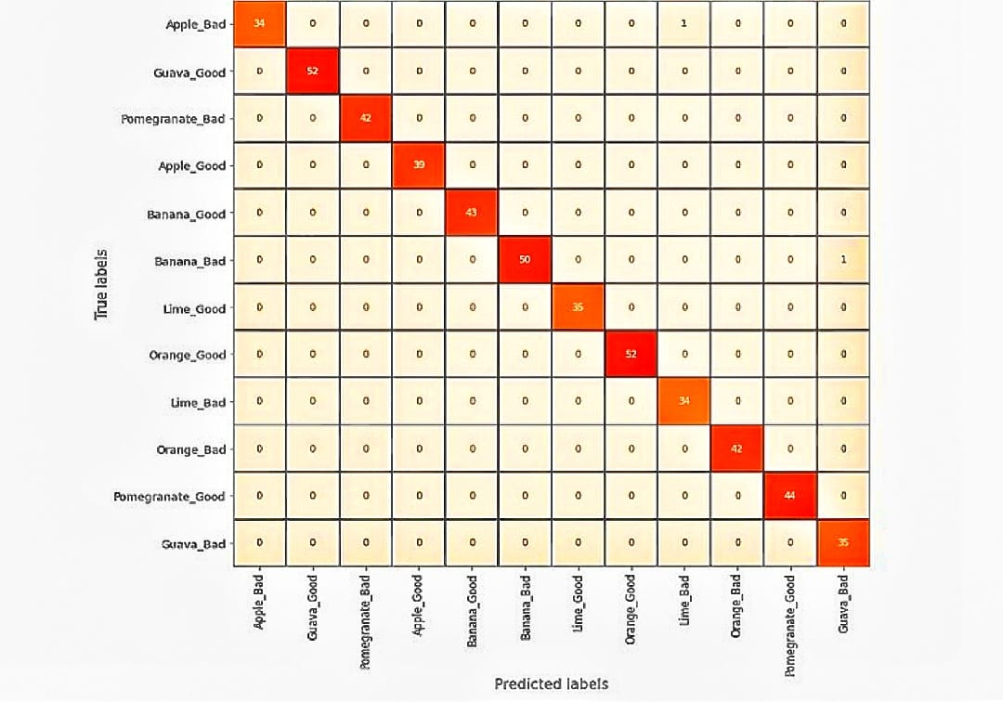

Fig4.3 Confusion matrix

After training on 12,000 images and 500 tests to confirm and test each, this produces 99.4% accuracy.

# 

# Analysis

Fruits detection is a very important factor in the agricultural industry. Farmers are much affected in the classification of fresh and rotten fruits as compared to a machine. The machine takes less time and effort as compared to the human. So, the proposed model is to detect the freshness of the fruit. In this work, the collected data used two types of fruits (Fresh and Rotten) as input fruit images. The fruits are Apple, Guava, Banana, Lime, Orange, and Pomegranate. A Convolutional neural network extracts the features from fresh and rotten fruit images and Sigmoid is used as a classification function. The performance of the proposed model in the CNN model generated an accuracy of 99.44% on the dataset. The result shows that it can easily classify fresh and rotten fruits. We have also compared to some pre-trained like VGG16, MobileNet, XceptionNet, EfficientNet model as for comparison.

As a result, the presented CNN model allows for low-cost quality assessment and has broader potential uses in fruit quality prediction. The procedure is non-destructive and non-invasive, which serves to reduce fruit waste during quality control. Deep learning can be used to detect fruit quality quickly and quantitatively, and the proposed algorithmic framework might be used to detect other agricultural products as well.

# Conclusions and Future Work

Poor yields are a leading cause of financial problems for the agricultural agribusiness worldwide. It affects the quality and quality of the fruit. Quality monitoring is a time-consuming and very special process after harvest. The need for a fast-paced and slow-moving computer model that does not allow for excellent accuracy has been met with this proposed CNN model. After training in 12,000 photographs and 1200 tests to confirm and test each, this produces 99.44% accuracy. This model has for further improvement as to get the best training time without losing the accuracy that can be achieved, yet more promising is the prospect of using more classes in this model depending on the different types of fruit or even other plants grown throughout India and the world. The many types of fruits and vegetables that should be considered and their quality influence the way they spread.

References

[1] India economic survey 2018: Farmers gain as agriculture mechanisationspeeds up, but more rd needed”. the financial express.” 29 January 2018.Retrieved 8 January 2019J. Clerk Maxwell, A Treatise on Electricity and Magnetism, 3rd ed., vol. 2. Oxford: Clarendon, 1892, pp.68–73.

[2] “Palakodati, s.s.s., chirra, v.r., dasari, y., bulla, s. (2020). fresh and rotten fruits classification using cnn and transfer learning. revued’intelligenceartificielle, vol. 34, no. 5, pp. 617-622. https://doi.org/10.18280/ria.340512.”

[3] “Indian food processing, india brand equity foundation. retrieved 22 august, 2021, (web-link: https://www.ibef.org/industry/indianfoodindustry.aspx).”

[4] P. Mishra, D. N. Rutledge, J.-M. Roger, K. Wali, and H. A. Khan, “Chemometric pre-processing can negatively affect the performance of near-infrared spectroscopy models for fruit quality prediction,” Talanta, vol. 229, p. 122303, 2021. [Online]. Available: https://www.sciencedirect.com/science/article/pii/S0039914021002241

[5] ] M. Afonso, H. Fonteijn, F. S. Fiorentin, D. Lensink, M. Mooij, N. Faber, G. Polder, and R. Wehrens, “Tomato fruit detection and counting in greenhouses using deep learning,” Frontiers in Plant Science, vol. 11, p. 1759, 2020. [Online]. Available: https://www.frontiersin.org/article/10.3389/fpls.2020.571299

[6] A. Z. da Costa, H. E. Figueroa, and J. A. Fracarolli, “Computer vision based detection of external defects on tomatoes using deep learning,” Biosystems Engineering, vol. 190, pp. 131–144, 2020. [Online]. Available: https://www.sciencedirect.com/science/article/pii/S1537511019309109

[7] R. C. Joshi, M. Kaushik, M. K. Dutta, A. Srivastava, and N. Choudhary, “Virleafnet: Automatic analysis and viral disease diagnosis using deep-learning in vigna mungo plant,” Ecological Informatics, vol. 61, p. 101197, 2021. [Online]. Available: https://www.sciencedirect.com/science/article/pii/S1574954120301473

[8] S. Fan, J. Li, Y. Zhang, X. Tian, Q. Wang, X. He, C. Zhang, and W. Huang, “On line detection of defective apples using computer vision system combined with deep learning methods,” Journal of Food Engineering, vol. 286, p. 110102, 04 2020

[9] “Bhargava, a., bansal, a. goyal, v. machine learning–based detection and sorting of multiple vegetables and fruits. food anal. methods (2021). https://doi.org/10.1007/s12161-021-02086-1.”

[10] R. G. Z. E. M. Gokt ¨ urk, “A system based on image processing and ¨ deep cnn features for classification of defective fruits,” International Conference on Advanced Technologies, Computer Engineering and Science, 2019.

[11] D. Mohapatra, B. Choudhury, and B. Sabat, “An automated system for fruit gradation and aberration localisation using deep learning,” vol. 1, pp. 6–10, 2021.

[12] C. S. . P. S. Roy, K., “Deep learning based real-time industrial framework for rotten and fresh fruit detection using semantic segmentation,” MicrosystTechnol, vol. 3365–3375, no. 18, 2021.

[13] F. Valentino, T. W. Cenggoro, and B. Pardamean, “A design of deep learning experimentation for fruit freshness detection,” 11 2020

[14] V. Meshram, K. Thanomliang, S. Ruangkan, P. Chumchu, and K. Patil, “Fruitsgb: Top indian fruits with quality,” 2020. [Online]. Available: https://dx.doi.org/10.21227/gzkn-f379d